BIT 4107 – Mobile Application Development
ENHANCED PROFESSIONAL STUDENT LOGBOOK
Student Name: KEVIN NYANGWESO MAGIVOI
Admission Number: BIT/2024/33671
School/Faculty: COMPUTING AND INFORMATICS
Programme: Bcs. IT
Academic Year: 2025/2026
Semester: MAY - AUGUST
Lecturer: MICHAEL NYORO
Phone Number:

Instructions
This logbook is used to document weekly learning activities, practical exercises, skills acquired, challenges encountered, solutions applied, and reflections. Students should complete all sections every week.
Each week to follow remarks in week 1 section.

Autogenerated Table of content

Week 1: Introduction to Mobile Application Development
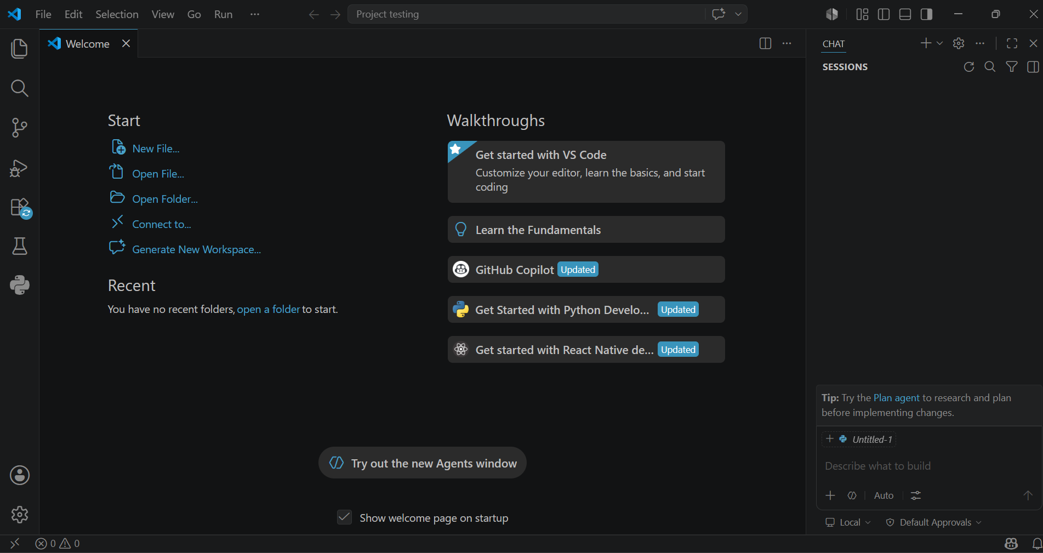
Figure 1: VS CODE
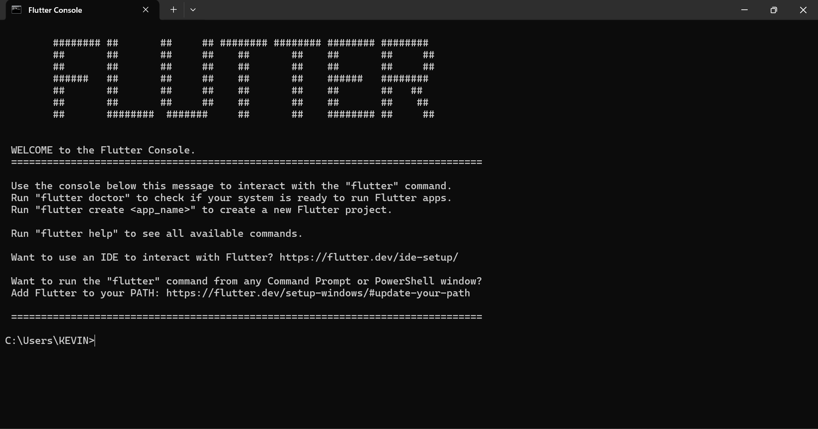
Figure 2: FLUTTER
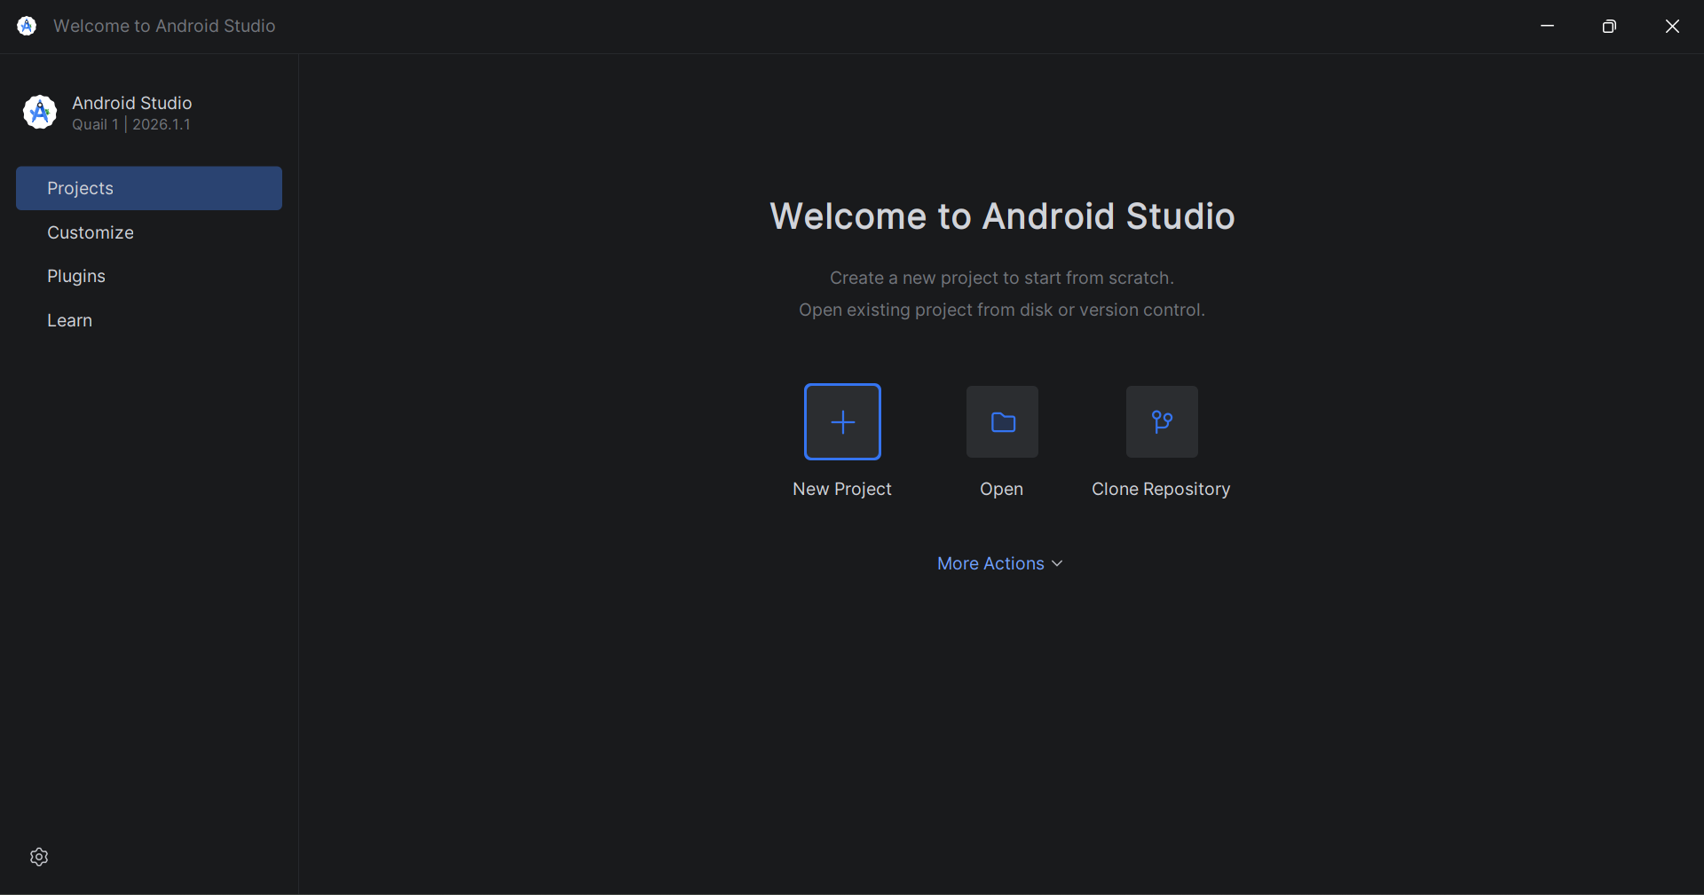
FIGURE 3: ANDROID STUDIO

Practical Activities Undertaken
only screenshots needed and labeling
Screenshots/Evidence Attached (Yes/No)

Tools/Software Used
- VS code
- Flutter
- Android Studio

Personal Reflection
Week 1 introduced me to Flutter and mobile development. I built the FreshMart Splash Screen, learning about widgets, animations, and navigation. Setting up the Android emulator was challenging, but seeing my animated screen run on a Pixel 8 emulator was rewarding and motivating for the weeks ahead.

Week 2: Mobile Development Environment
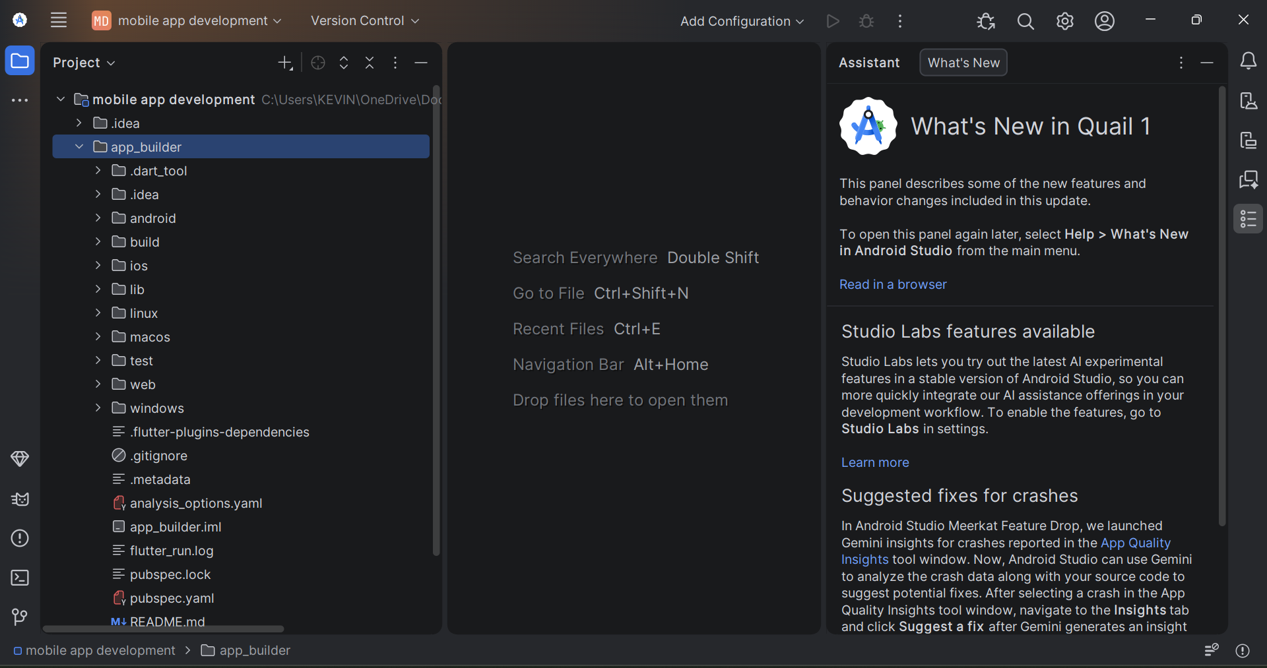
Figure 4: Android Studio IDE
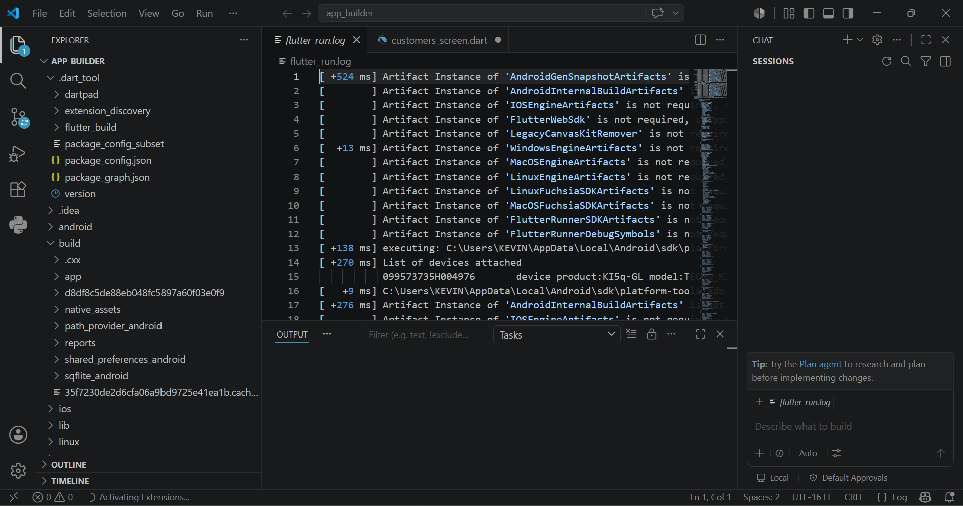
Figure 5: VS Code IDE
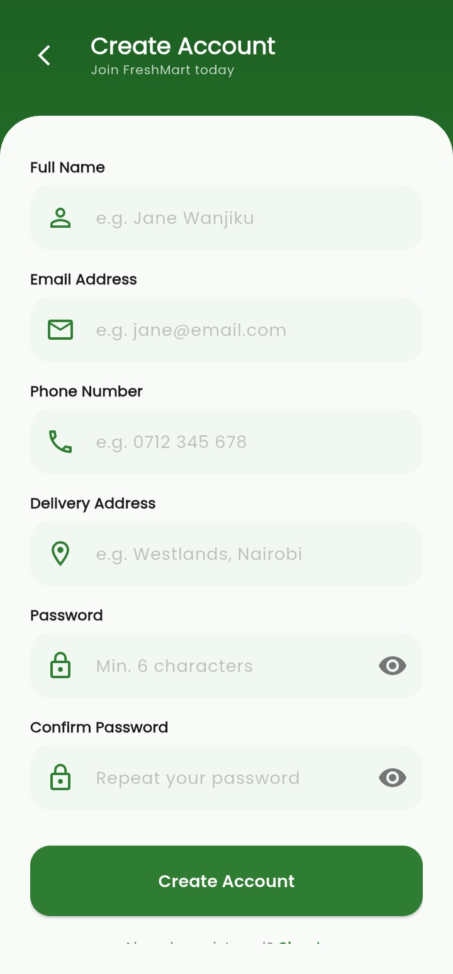
Figure 6: Sign-up page
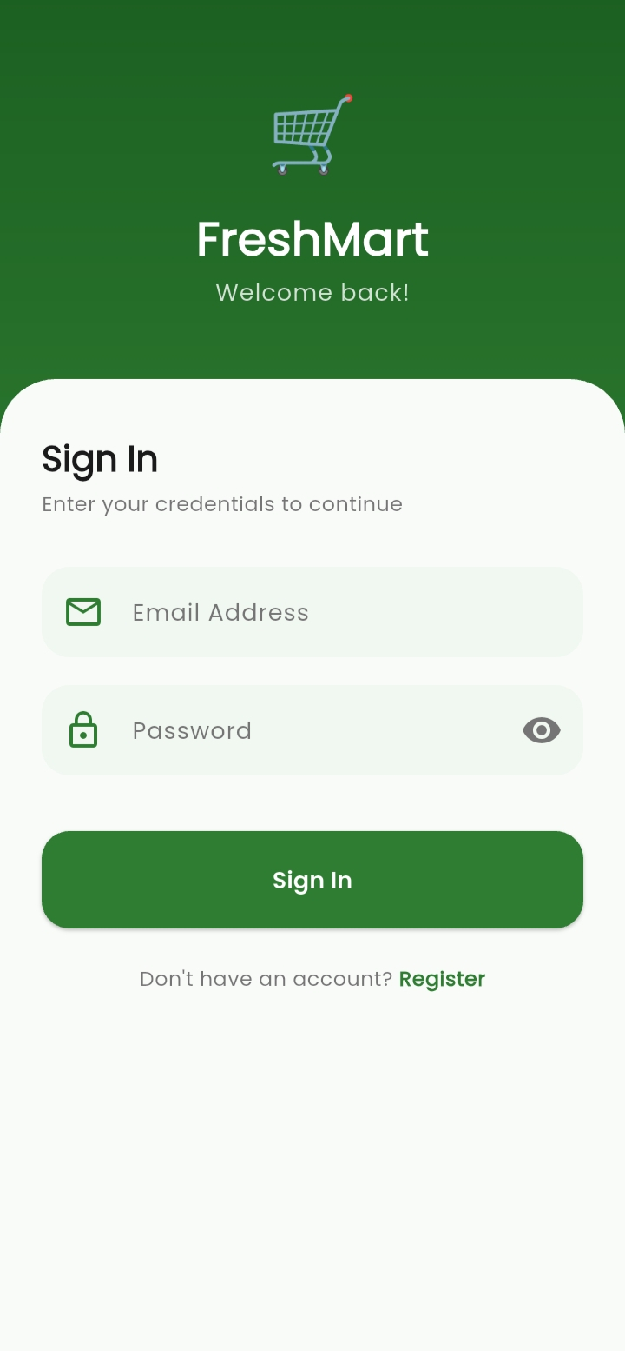
Figure 7: Login page

Personal Reflection
Week 2 involved building the Login and Registration screens with form validation. Saving customer records to SQLite using sqflite was challenging but insightful. Learning how GlobalKey<FormState> validates inputs and how SharedPreferences persists login sessions deepened my understanding of Flutter's data management capabilities.

Week 3: User Interface Design
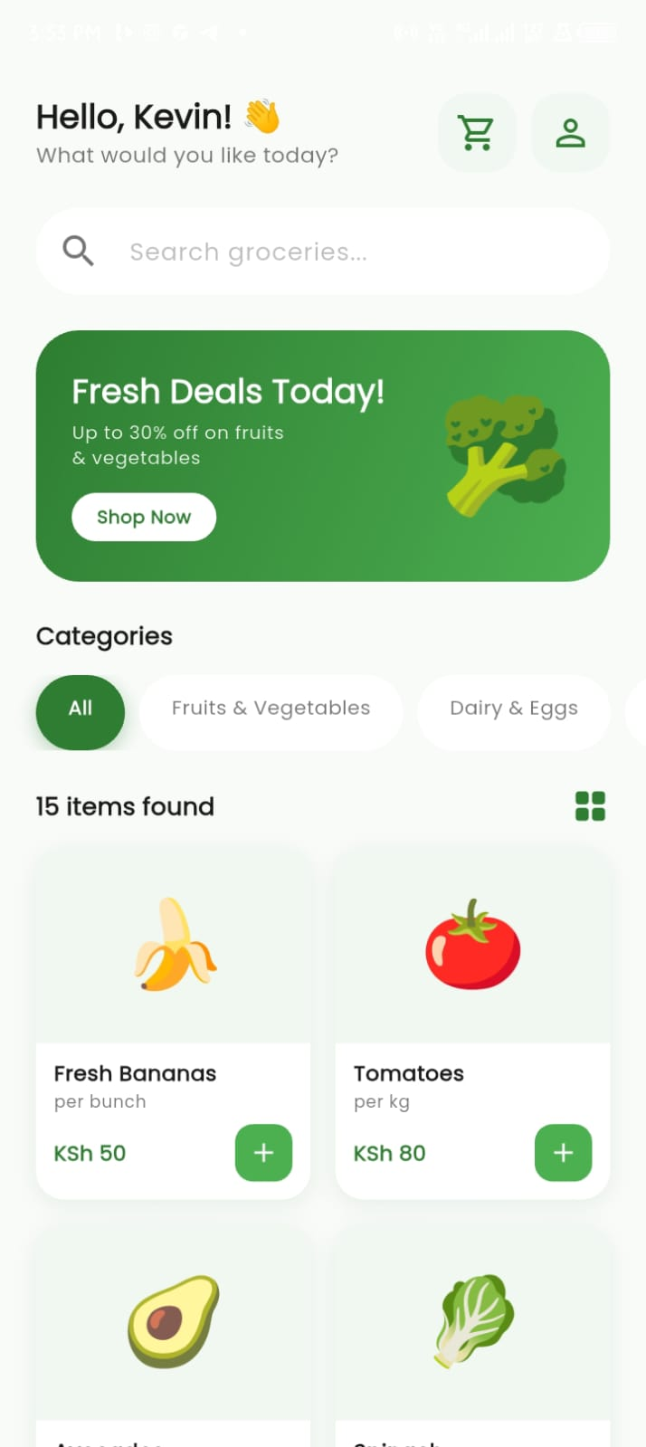
Figure 8: Home page
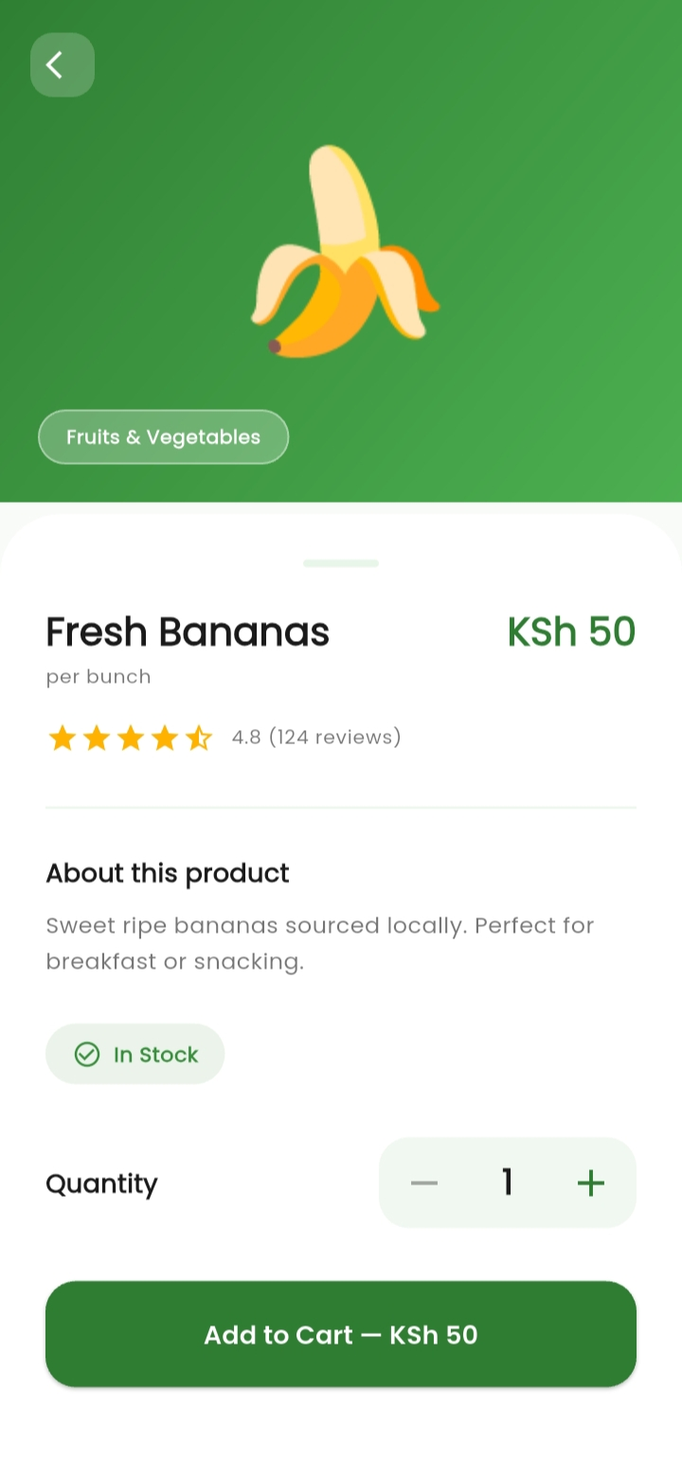
Figure 9: Product details page
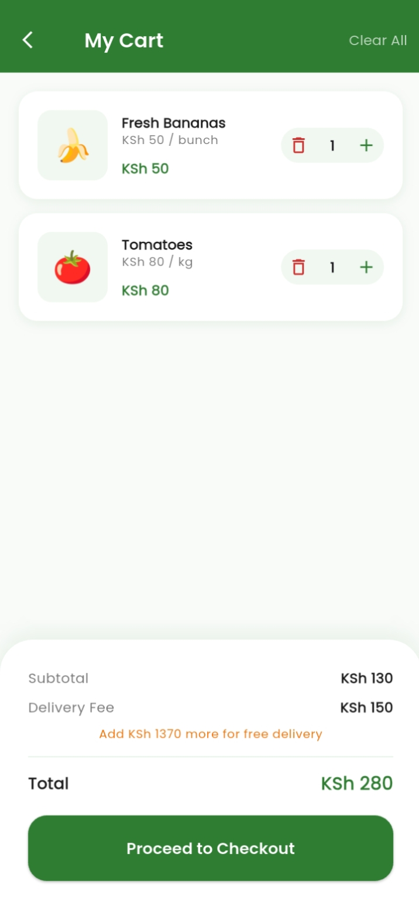
Figure 10: Cart

Personal Reflection
Week 3 involved building the Home Screen, Product Detail Screen, and Cart Screen. Implementing category filtering, search, quantity selectors, and a dynamic order summary with free delivery logic was rewarding. Using Draggable Scrollable Sheet and Dismissible widgets introduced me to more advanced Flutter UI components.

Week 4: Event Handling and User Interaction
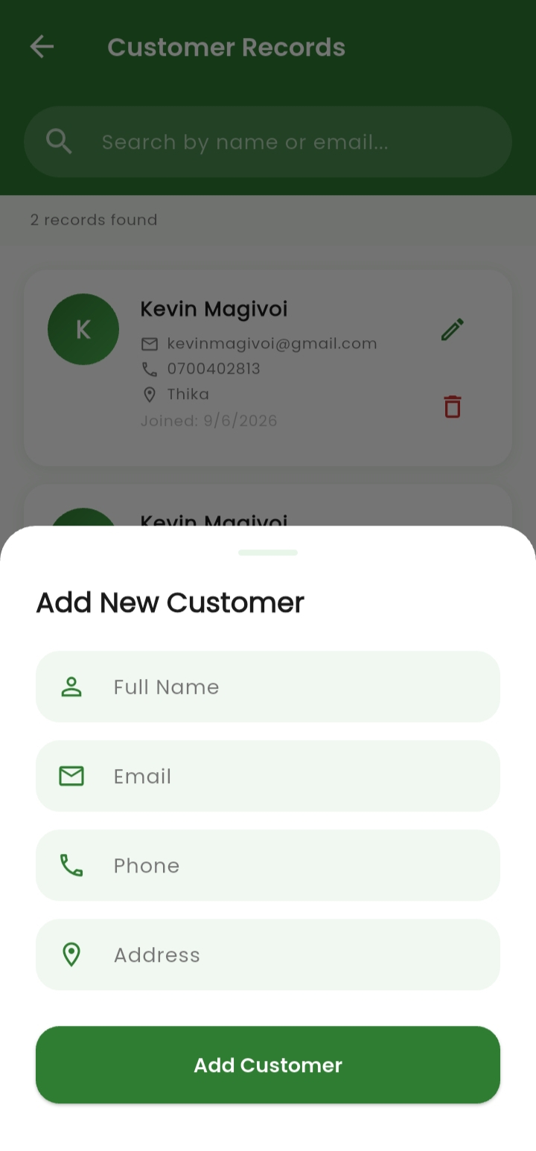
Figure 11: Event handling

Personal Reflection
Week 4 focused on building the Customer Records screen with SQLite CRUD operations. Implementing interactive event handling—such as live search filtering, form validations in show Modal Bottom Sheet, and confirmation dialogs—was challenging but significantly deepened my understanding of state management, local database manipulation, and responsive user interaction design in Flutter.

Week 5: Data Management

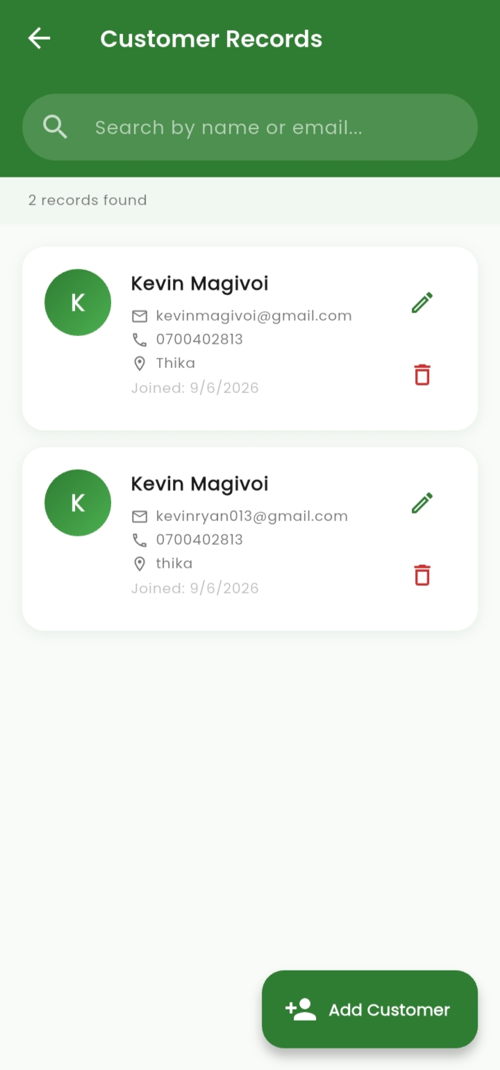
Figure 12: Customer records
Personal Reflection
Week 5 focused on building the Customer Records screen with full SQLite CRUD operations — Create, Read, Update, and Delete. Implementing live search, ListView for displaying records, and show Modal Bottom Sheet for inline forms was challenging but significantly deepened my understanding of local database management in Flutter.

Week 6: Networking and APIs

Same as week 1

Week 7: Application Architecture

Same as week 1

Week 8: Project Planning

Week 9: Device Features and Sensors

Same as week 1

Week 10: Notifications and Background Services

Same as week 1

Week 11: Mobile Security

Same as week 1

Week 12: Testing and Debugging

Same as week 1

Week 13: Application Deployment

Same as week 1

Week 14: Final Project Presentation

Same as week 1

Semester Project Tracking

Project Title

Project Objectives

Project Requirements

Development Milestones

Testing Results

Lessons Learned

Future Improvements

End of Semester Reflection

Summary of Skills Acquired

Most Interesting Topic

Major Challenges Faced

How Challenges Were Overcome

Professional Growth Achieved

Overall Course Experience

Final Approval
Student Name: __________________________
Student Signature: ______________________
Date: _________________________________
Lecturer Name: _________________________
Lecturer Remarks: _____________________
Date: _________________________________

